## Week 6 Homework Submission File: Advanced Bash - Owning the System

Please edit this file by adding the solution commands on the line below the prompt.

Save and submit the completed file for your homework submission.

**Step 1: Shadow People**

1. Create a secret user named `sysd`. Make sure this user does not have a home folder created:

- `Your solution command here`

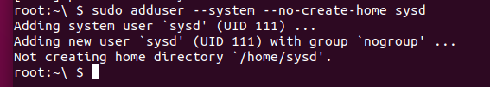

2. Give your secret user a password:

- `Your solution command here`



3. Give your secret user a system UID < 1000:

- `Your solution command here`



4. Give your secret user the same GID:

- `Your solution command here`



5. Give your secret user full `sudo` access without the need for a password:

- `Your solution command here`



6. Test that `sudo` access works without your password:

**Sudo -l**





```bash

Your bash commands here

``` 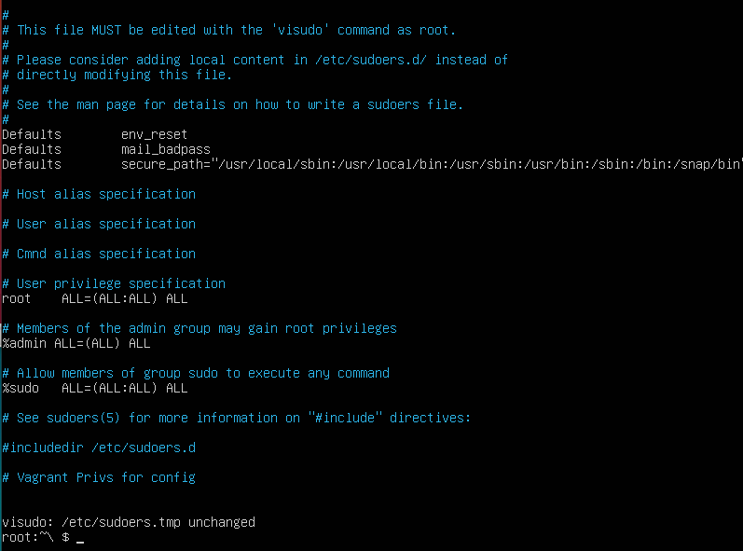

**Step 2: Smooth Sailing**

1. Edit the `sshd_config` file:



sudo

```bash

Your bash commands here

```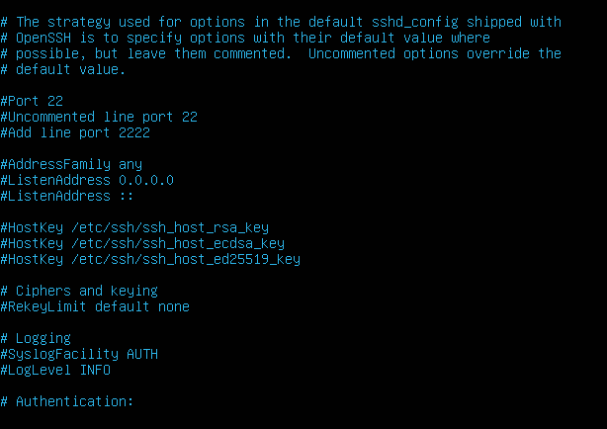

**Step 3: Testing Your Configuration Update**

1. Restart the SSH service:

- `Your solution command here`



2. Exit the `root` account:

- `Your solution command here`



3. SSH to the target machine using your `sysd` account and port `2222`:

- `Your solution command here`



4. Use `sudo` to switch to the root user:

- `Your solution command here`



**Step 4: Crack All the Passwords**

1. SSH back to the system using your `sysd` account and port `2222`:

- `Your solution command here`



2. Escalate your privileges to the `root` user. Use John to crack the entire `/etc/shadow` file:

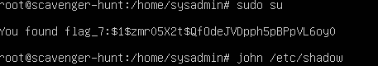

- `Your solution command here`

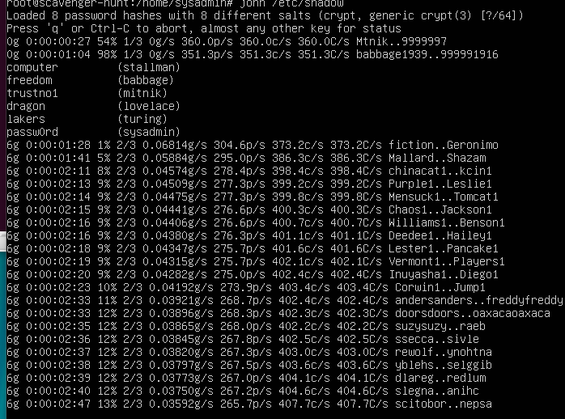

---

© 2020 Trilogy Education Services, a 2U, Inc. brand. All Rights Reserved.